Applecross Senior High School

Semester One Examination, 2020

Question/Answer booklet

MATHEMATICS

SOLUTIONS
METHODS
UNIT 1

Section Two:

Calculator-assumed

WA student number: In figures

In words

Your name

Number of additional
answer booklets used
(if applicable):

Time allowed for this section
Reading time before commencing work: ten minutes
Working time: one hundred minutes

Materials required/recommended for this section
To be provided by the supervisor
This Question/Answer booklet
Formula sheet (retained from Section One)

To be provided by the candidate
Standard items: pens (blue/black preferred), pencils (including coloured), sharpener,
correction fluid/tape, eraser, ruler, highlighters

Special items: drawing instruments, templates, notes on two unfolded sheets of A4 paper, and up to three calculators approved for use in this examination

Important note to candidates
No other items may be taken into the examination room. It is your responsibility to ensure that you do not have any unauthorised material. If you have any unauthorised material with you, hand it to the supervisor before reading any further.

Structure of this paper

Section | Number of  questions  available | Number of  questions to  be answered | Working  time  (minutes) | Marks  available | Percentage  of  examination
Section One:  Calculator-free | 8 | 8 | 50 | 52 | 35
Section Two:  Calculator-assumed | 13 | 13 | 100 | 98 | 65
 |  |  |  | Total | 100

Instructions to candidates

1. The rules for the conduct of examinations are detailed in the school handbook. Sitting this examination implies that you agree to abide by these rules.

2. Write your answers in this Question/Answer booklet preferably using a blue/black pen.
Do not use erasable or gel pens.

3. You must be careful to confine your answers to the specific question asked and to follow any instructions that are specific to a particular question.

4. Show all your working clearly. Your working should be in sufficient detail to allow your answers to be checked readily and for marks to be awarded for reasoning. Incorrect answers given without supporting reasoning cannot be allocated any marks. For any question or part question worth more than two marks, valid working or justification is required to receive full marks. If you repeat any question, ensure that you cancel the answer you do not wish to have marked.

5. It is recommended that you do not use pencil, except in diagrams.

6. Supplementary pages for planning/continuing your answers to questions are provided at the end of this Question/Answer booklet. If you use these pages to continue an answer, indicate at the original answer where the answer is continued, i.e. give the page number.

7. The Formula sheet is not to be handed in with your Question/Answer booklet.
Section Two: Calculator-assumed 65% (98 Marks)
This section has thirteen questions. Answer all questions. Write your answers in the spaces provided.

Working time: 100 minutes.

Question 9 (5 marks)
Shape $AOBCDA$ below consists of sector $BOC$ of circle centre $O$ joined to sector $DOA$ of a different circle, also centre $O$. $AB$ is a straight line of length $65$ cm, arc $AD$ is $12$ cm long and $∠AOD=0.32$ radians.
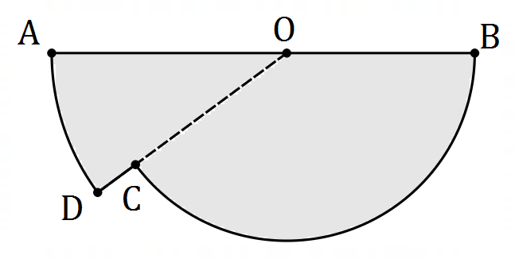

(a) Determine the length $OA$. (2 marks)
Solution
Let $OA=R$ so that
$$0.32R=12 \\ R=37.5 \text{cm}$$

Specific behaviours
correct use of arc length
✓ correct length

(b) Determine the area of the shape. (3 marks)
Solution
$$A_{DOA}=\frac{1}{2}×{37.5}^{2}×0.32 \\ =225$$
Let $OB=r$
$$r=65-37.5 \\ =27.5$$

$$A_{BOC}=\frac{1}{2}×{27.5}^{2}\left(π-0.32\right) \\ =1067$$

$$\text{Area}=225+1067 \\ =1 292 {\text{cm}}^{2}$$

Specific behaviours
area of sector $DOA$
✓ radius and angle of sector $BOC$
✓ area of shape

Question 10 (8 marks)
The height $h$ metres of a particle above level ground is defined as a function of time $t$ seconds as follows:
$$h\left(t\right)=68.75+15t-5t^{2}, 0≤t≤5.5 .$$

(a) Determine the height of the particle when

(i) $t=0$. (1 mark)
Solution
$$h\left(0\right)=68.75 \text{m}$$

$$h\left(4.5\right)=35 \text{m}$$

Specific behaviours
(i) correct
✓ (ii) correct

(ii) $t=4.5$. (1 mark)

(b) Determine the maximum height reached by the particle and the time it reached this height.
(2 marks)
Solution
From graph of $h(t)$:

Maximum height: $h=80 \text{m}$ when $t=1.5 \text{s}$.

Specific behaviours
correct height
✓ correct time

(c) Determine the time(s) that the particle was at a height of $75$ m. (2 marks)
Solution
From graph of $h(t)$:

$h=75$ when $t=0.5 \text{s}, 2.5 \text{s}$

Specific behaviours
one time
✓ both times

(d) State the range of the function $h(t)$ for the given domain. (2 marks)
Solution
Range of $h$:

$$0≤h≤80$$

Specific behaviours
upper limit
✓ lower limit, correct inequality

Question 11 (6 marks)
Two events are such that $P\left(X\right)=0.2$, $P\left(Y\right)=0.5$ and $P\left(Y | X\right)=0.1$.

Determine the probability that

(a) both events occur. (2 marks)
Solution
$$P\left(Y | X\right)=\frac{P(X∩Y)}{P(X)}⇒P\left(X∩Y\right)=0.2×0.1=0.02$$

Specific behaviours
indicates use of conditional formula
✓ correct probability

(b) at least one event occurs. (2 marks)
Solution
$$P\left(X∪Y\right)=P\left(X\right)+P\left(Y\right)-P\left(X∩Y\right) \\ =0.2+0.5-0.02 \\ =0.68$$

Specific behaviours
indicates use of rule
✓ correct probability

(c) neither event occurs. (1 mark)
Solution
$$P\left(X∩Y\right)=1-P\left(X∪Y\right) \\ =1-0.68 \\ =0.32$$

Specific behaviours
✓ correct probability

(d) $X$ occurs given that $Y$ has occurred. (1 mark)
Solution
$$P\left(X | Y\right)=\frac{P\left(X∩Y\right)}{P\left(Y\right)} \\ =\frac{0.02}{0.5} \\ =0.04$$

Specific behaviours
✓ correct probability

Question 12 (8 marks)
The height above ground level, $h$ m, of a seat on a steadily rotating Ferris wheel $t$ minutes after the wheel begins to move is given by $h=21.5-18.5\cos\left(\begin{matrix}πt \\ \overline{ 6 }\end{matrix}+\begin{matrix}π \\ \overline{3}\end{matrix}\right).$

(a) Determine the initial height of the seat. (1 mark)
Solution
$$h\left(0\right)=12.25 \text{m}$$
Specific behaviours
correct height

(b) Graph the height of the seat against time on the axes below. (4 marks)
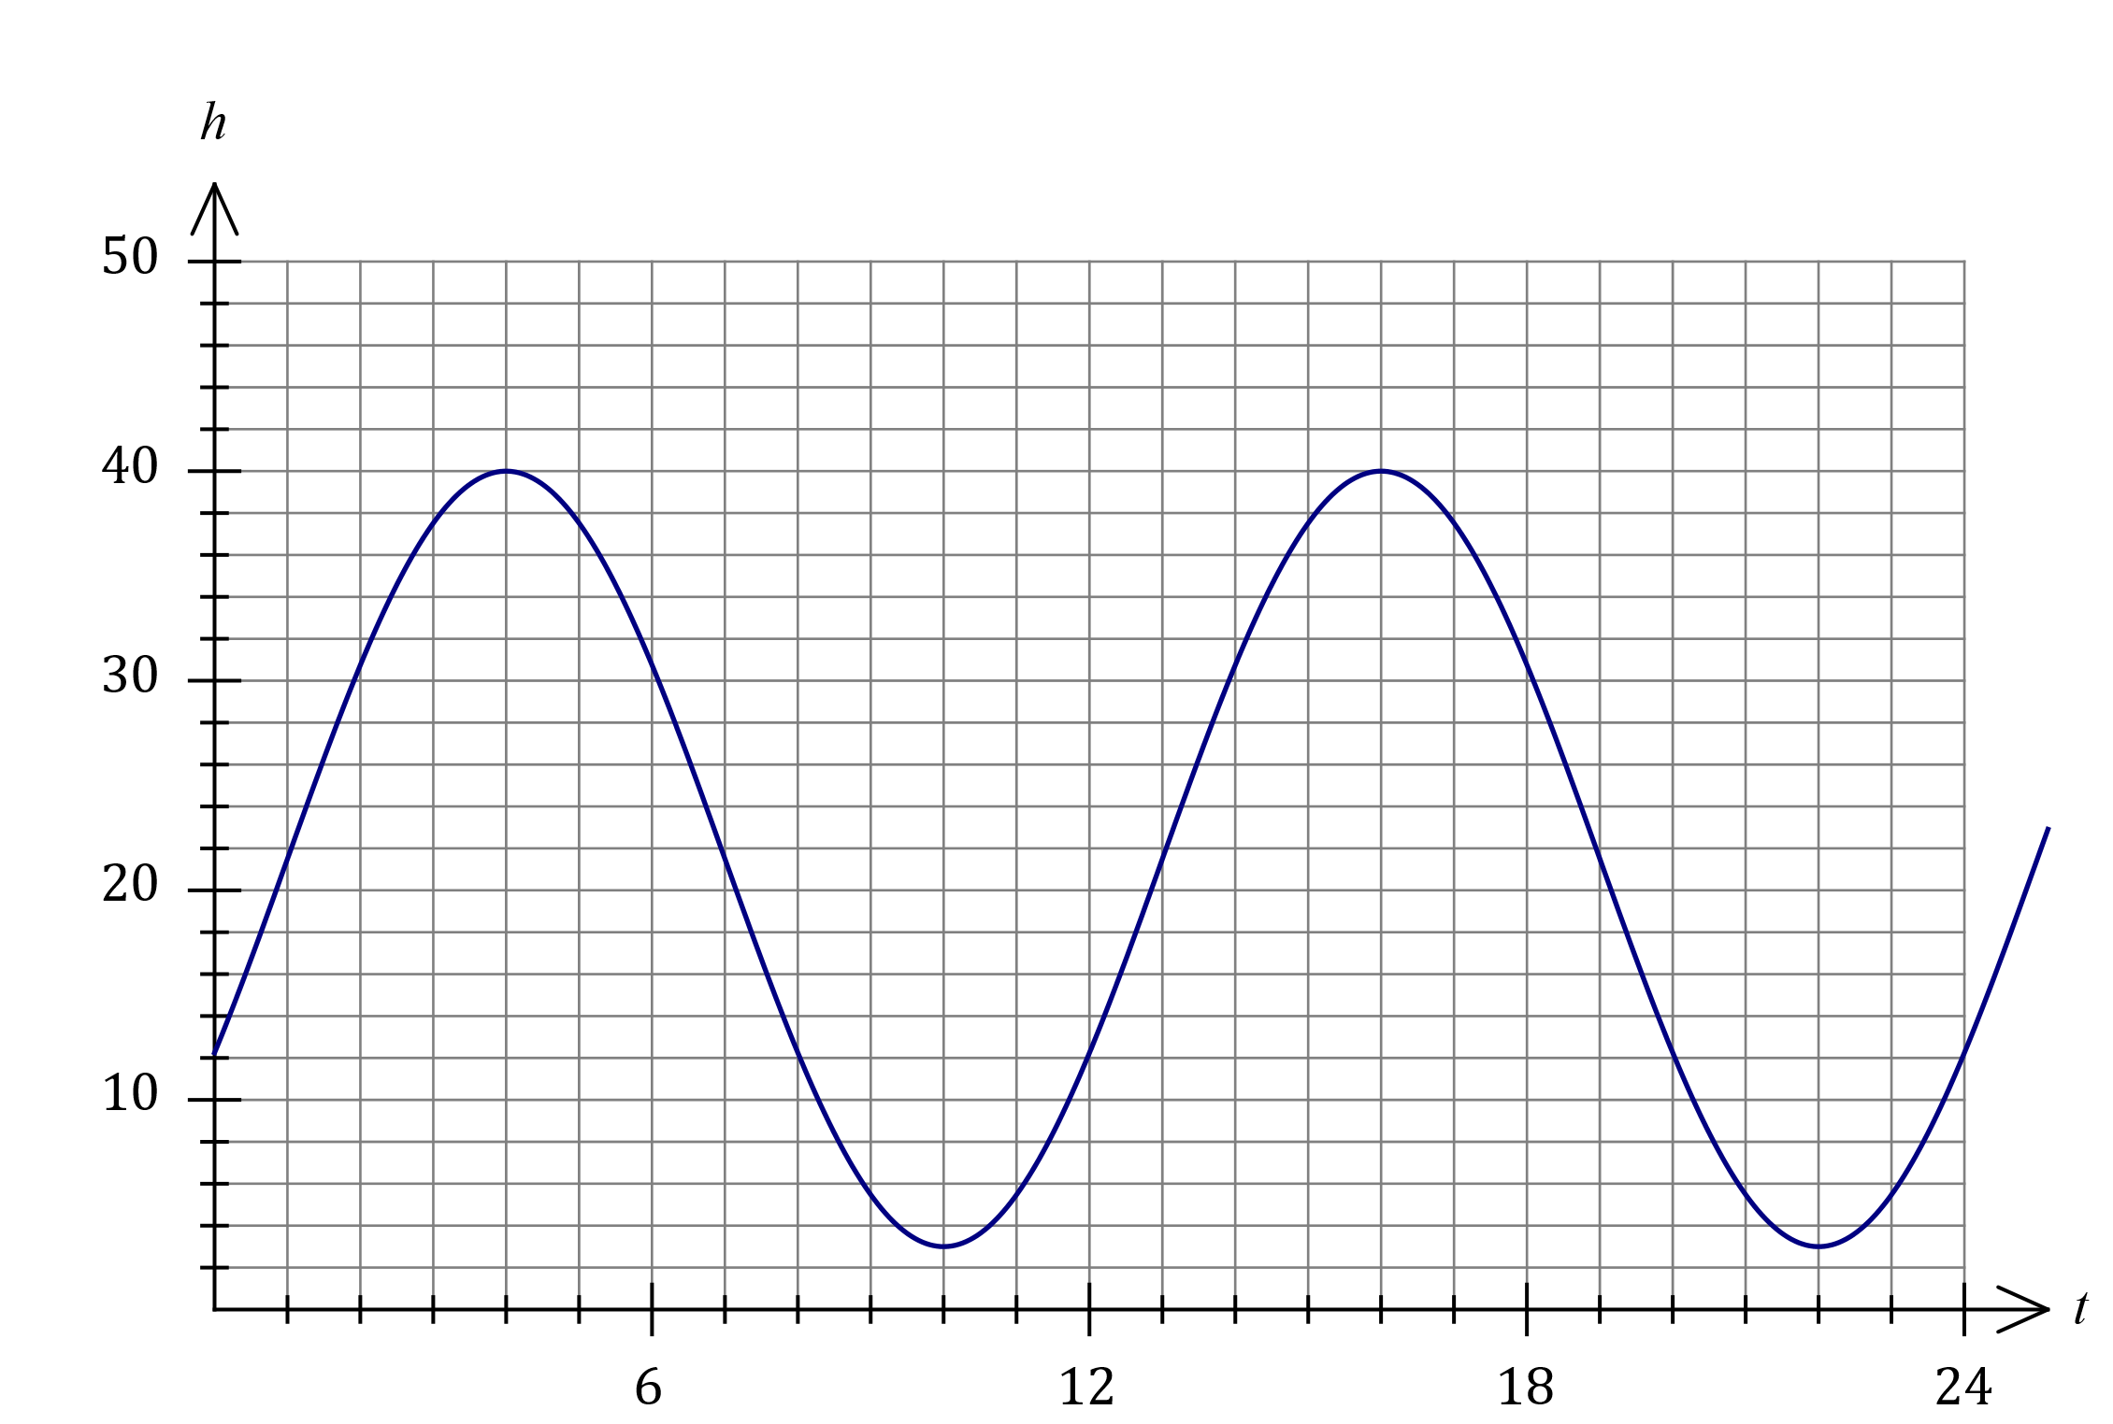
Solution
See graph
Specific behaviours
$(0, 12)$ and $(24, 12)$
✓ correct maximums
✓ correct minimums
✓ smooth curve

(c) Determine

(i) the maximum height above ground reached by the seat. (1 mark)
Solution
$$h_{MAX}=40 \text{m}$$
Specific behaviours
correct height

(ii) the time taken, to the nearest second, for the seat to first reach a height of $4$ m above ground level. (2 marks)
Solution
$$h=4⇒t=9.37$$
$$0.37×60=22$$
$$t=9 \text{m} 22 \text{s} (562 \text{s})$$
Specific behaviours
time as decimal
✓ time to nearest second

Question 13 (6 marks)
The graph $y=f(x)$, where $f(x)=x^{2}+bx+c$ has a turning point at $(2, -7)$.

(a) State the equation of the line of symmetry for the graph of $y=f(x)$. (1 mark)
Solution
$$x=2$$

Specific behaviours
correct equation

(b) Determine the value of the constant $b$ and the value of the constant $c$. (3 marks)
Solution
$$f(x)={\left(x-2\right)}^{2}-7 \\ =x^{2}-4x+4-7$$

$$b=-4$$

$$c=-3$$

Specific behaviours
writes $f(x)$ in squared form
✓ value of $b$
✓ value of $c$

(c) The graph of $y=f(x)$ is translated $3$ units to the left and $2$ units upwards. Determine the equation of the resulting curve. (2 marks)
Solution
New turning point at $\left(2-3, -7+2\right)=(-1, -5)$.

Equation is $y={\left(x+1\right)}^{2}-5=x^{2}+2x-4$

Specific behaviours
identifies new turning point
✓ correct equation (either form)

Question 14 (6 marks)
When a random sample of $173$ people from a university were classified according to whether they had a driver's licence (event $D$) and whether they wore spectacles (event $S$), it was observed that $n\left(D\right)=140$, $n\left(S\right)=53$ and $n\left(S∩\overline{D}\right)=10$.

(a) Determine

(i) $n(\overline{S})$. (1 mark)
Solution
$$n\left(\overline{S}\right)=173-53=120$$

Specific behaviours
correct number

(ii) $n(D∩S)$. (1 mark)
Solution
$$n\left(D∩S\right)=53-10=43$$

Specific behaviours
correct number

(b) Determine the probability that a randomly chosen person from the sample

(i) does not have a driver's licence. (2 marks)
Solution
$$n\left(\overline{D}\right)=173-140=33 \\ P\left(\overline{D}\right)=\frac{33}{173}≈0.191$$

Specific behaviours
numerator
✓ denominator

(ii) wears spectacles given that they have a driver's licence. (2 marks)
Solution
$$P\left(S | D\right)=\frac{n\left(D∩S\right)}{n(D)}=\frac{43}{140}≈0.307$$

Specific behaviours
numerator
✓ denominator

Question 15 (8 marks)
Consider part of the unit circle shown below, where $θ=51°$.

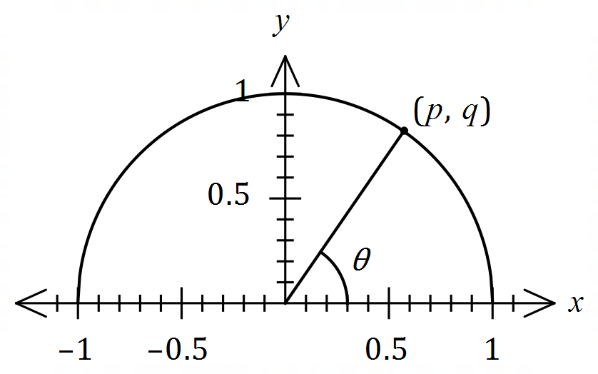

Determine, in terms of $p$ and / or $q$, an expression for each of the following:

(a) $\sin{51°}$. (1 mark)
Solution
$$\sin{51°}=q$$

Specific behaviours
correct expression

(b) $\cos{129°}$. (2 marks)
Solution
$$\cos{129°}=-\cos{51°} \\ =-p$$

Specific behaviours
✓ uses reflection
correct expression

Solution
$$\sin{141°}=\sin\left(51°+90°\right) \\ =\cos{51°} \\ =p$$

Specific behaviours
✓ uses fundamental relationship
correct expression

(c) $\sin{141°}$. (2 marks)

(d) $\cos{258°}$. (3 marks)

Solution
$$\cos{258°}=\cos\left(129°+129°\right) \\ =\cos{129°}\cos{129°}-\sin{129°}\sin{129°} \\ ={\left(-p\right)}^{2}-{\left(q\right)}^{2} \\ =p^{2}-q^{2}$$

Specific behaviours
✓ halves angle
✓ uses sum identity
correct expression

Question 16 (8 marks)
A polynomial of degree $3$ passes through the points with coordinates $\left(0, 4\right), \left(-2, 0\right), (2, 0)$ and $\left(0.5, 0\right)$.

(a) Determine the equation of the polynomial in expanded form. (4 marks)
Solution
Using roots:
$$y=a(x+2)(x-2)(x-0.5)$$

Use 4th point:
$$x=0⇒4=a\left(2\right)\left(-2\right)\left(-0.5\right) \\ a=2$$
Expand:
$$y=2(x+2)(x-2)(x-0.5) \\ =2x^{3}-x^{2}-8x+4$$

Specific behaviours
factored form using roots
✓ substitutes fourth point
✓ correct value of $a$
✓ correct expanded form

(b) Draw the graph of the polynomial on the axes below, indicating the coordinates of all turning points. (4 marks)

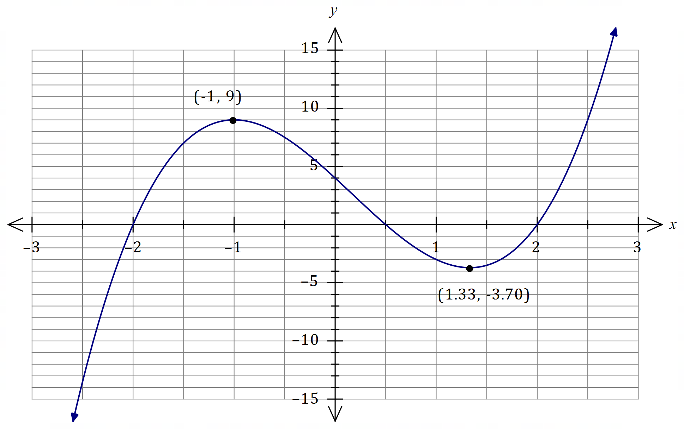
Solution
See graph
Specific behaviours
all roots and $y$-intercept
✓ labelled maximum
✓ labelled minimum
✓ smooth curve

Question 17 (7 marks)
Let $f\left(x\right)=1+\sqrt{6-2x}$ and $g\left(x\right)=x+2$.

(a) Evaluate $f\left(-5\right)-g(-5)$. (2 marks)
Solution
$$f\left(-5\right)-g\left(-5\right)=1+\sqrt{16}-\left(-5+2\right) \\ =5-\left(-3\right) \\ =8$$

Specific behaviours
evaluates $f$ correctly
✓ correct value

(b) State the domain of $f(x)$. (2 marks)
Solution
$$6-2x≥0 \\ -2x≥-6 \\ x≤3$$

Specific behaviours
correct inequality
✓ correct bound

(c) State the range of $g(x)$. (1 mark)
Solution
$$y∈R$$

Specific behaviours
correct range (symbols or words)

(d) Determine the coordinates of the point(s) of intersection of $y=f(x)$ and $y=g(x)$.
(2 marks)
Solution
Using graph/CAS:
$$(1, 3)$$

Specific behaviours
$x$-coordinate
✓ $y$-coordinate

Question 18 (8 marks)
The graph of $y=f(x)$ is drawn below, where $f\left(x\right)=\sqrt{x+a}+b$.

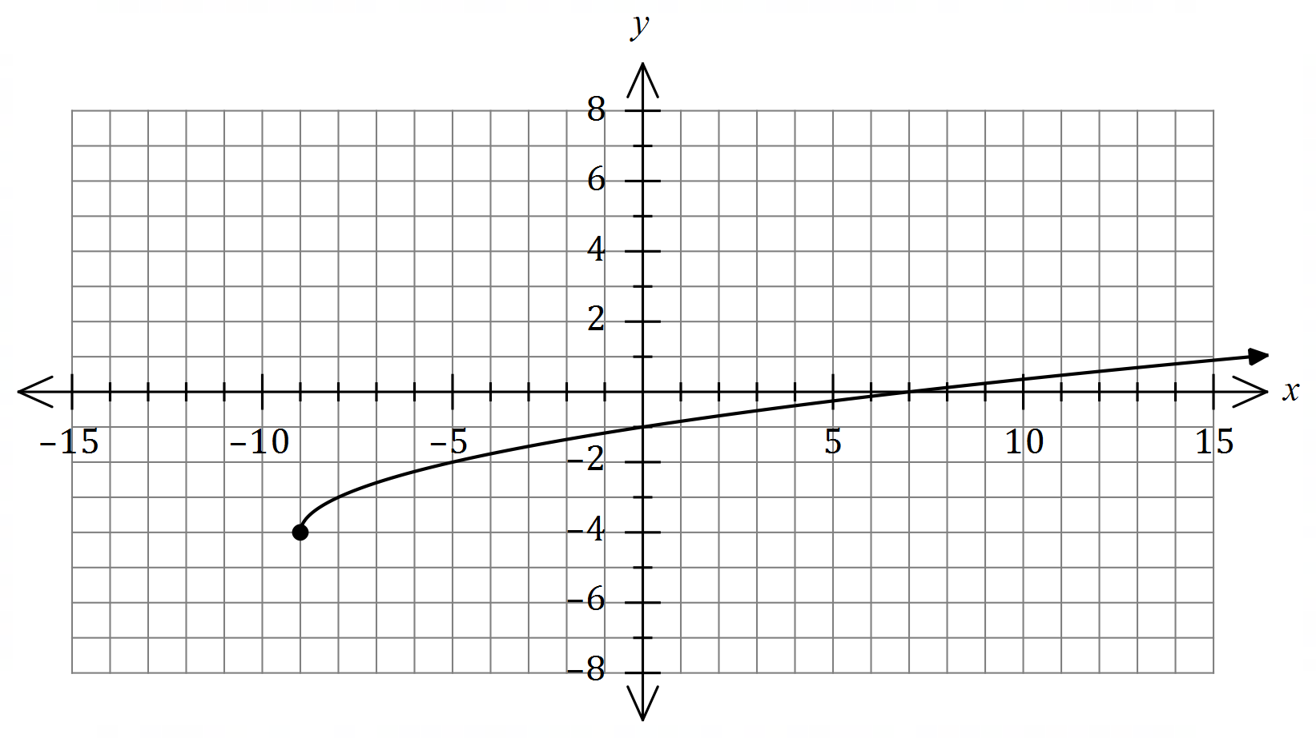

(a) Determine the value of the constant $a$ and the value of the constant $b$. (2 marks)
Solution
$$a=9, b=-4$$

Specific behaviours
value of $a$
✓ value of $b$

(b) Draw the graph of $y=-2f\left(x\right)$ on the axes below. (3 marks)

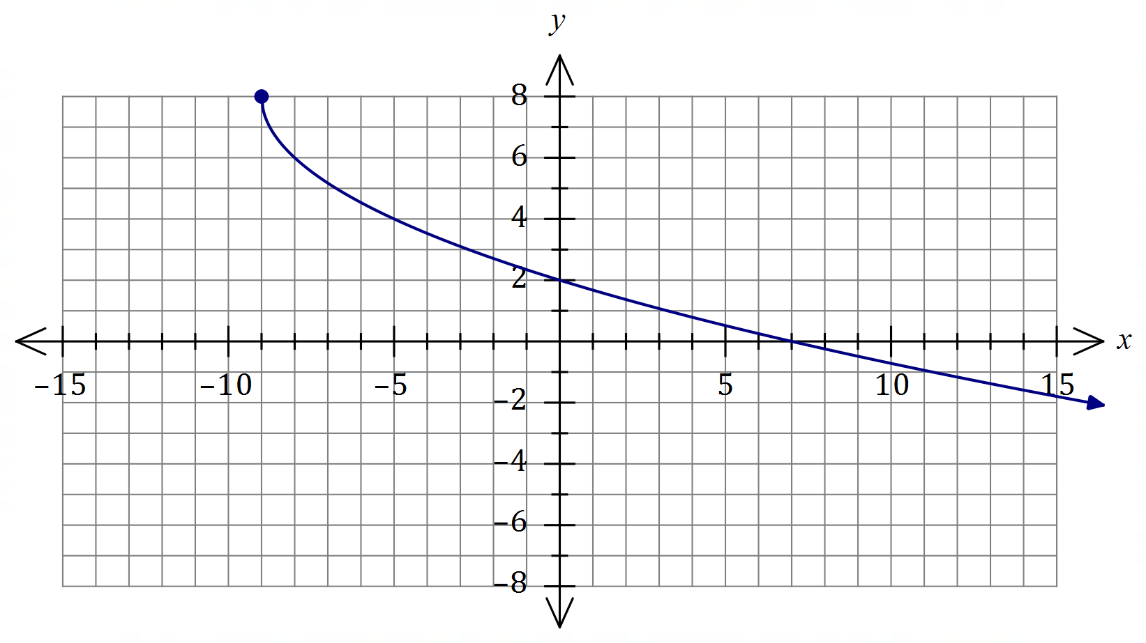
Solution
See graph
Specific behaviours
endpoint at $(-9, 8)$
✓ thru' $(0,2)$ and $(7, 0)$
✓ smooth curve

(c) Draw the graph of $y=f\left(2x\right)$ on the axes below. (3 marks)

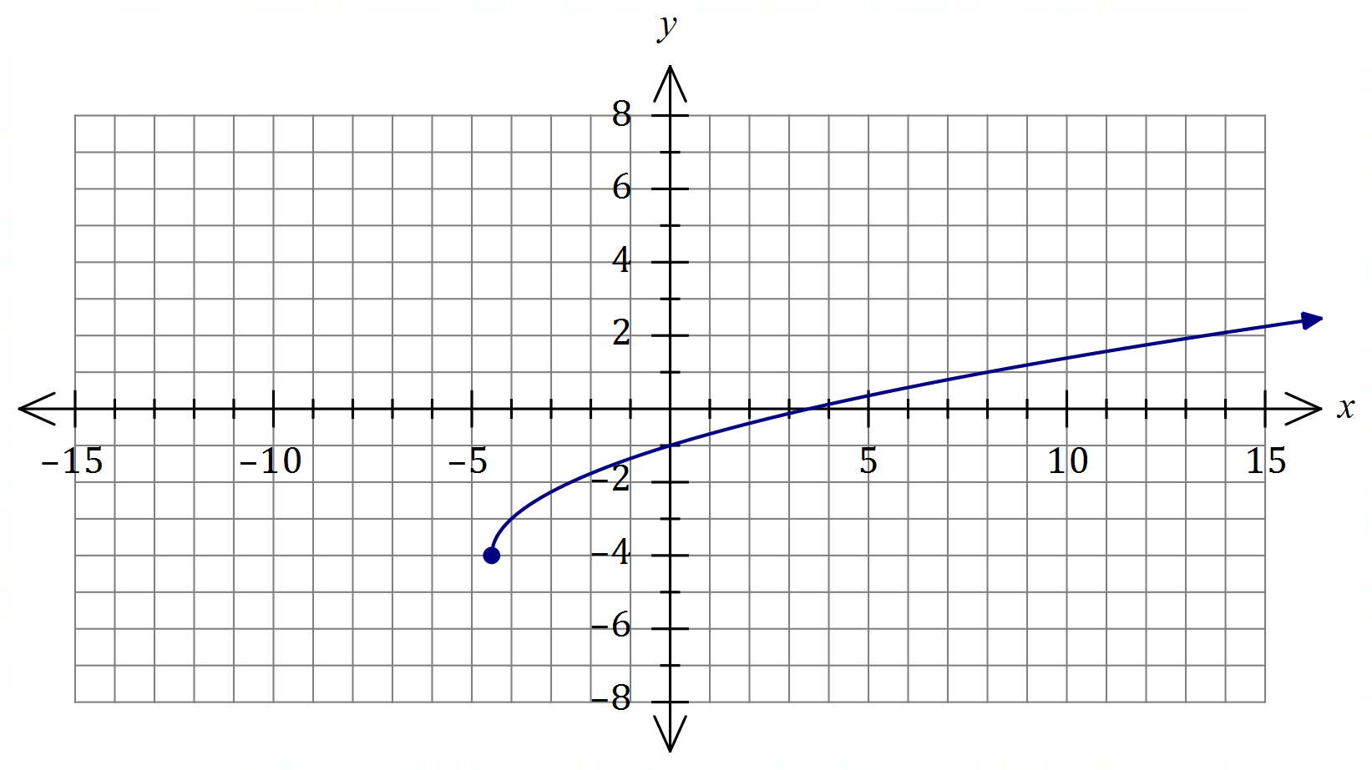
Solution
See graph
Specific behaviours
endpoint at $(-4.5, -4)$
✓ thru' $(0,-1)$ and $(3.5, 0)$
✓ smooth curve

Question 19 (9 marks)
The graph of $y=f(x)$ is shown, where $f\left(x\right)=\begin{matrix}a \\ \overline{x+b}\end{matrix}+c$ and $a, b$ and $c$ are constants.

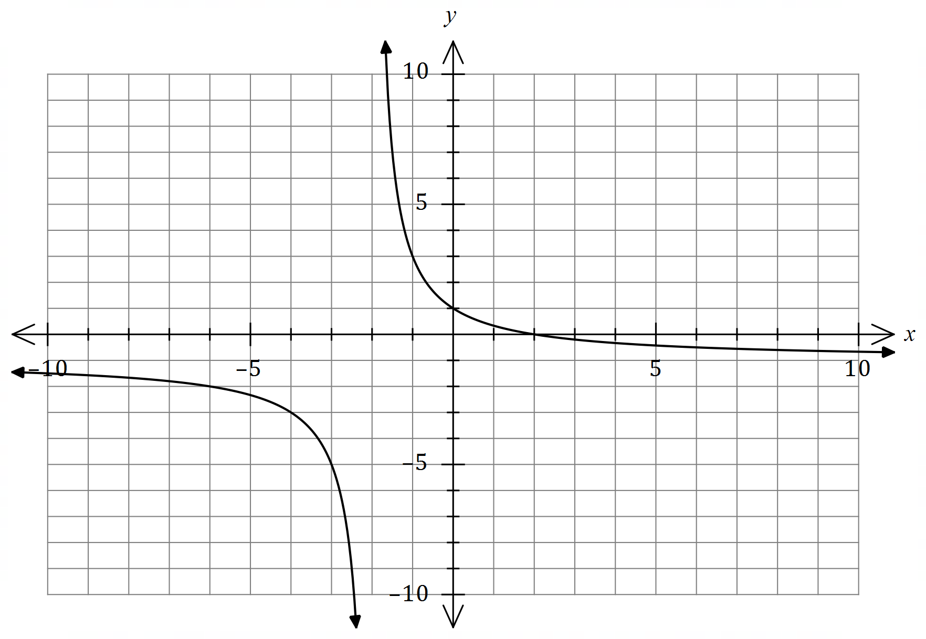

(a) Determine the value of $a$, the value of $b$ and the value of $c$. (3 marks)
Solution
$$b=2, c=-1$$

$$\left(0, 1\right)⇒1=\frac{a}{2}-1$$
$$a=4$$

Specific behaviours
value of $a$
value of $b$
value of $c$

(b) State the domain and range of $f(x)$. (2 marks)
Solution
Domain: $x≠-2$

Range: $y≠-1$

Specific behaviours
correct domain
✓ correct range

(c) On the axes below, draw the graph of $y=2-f(x)$ and label all asymptotes with their equations. (4 marks)

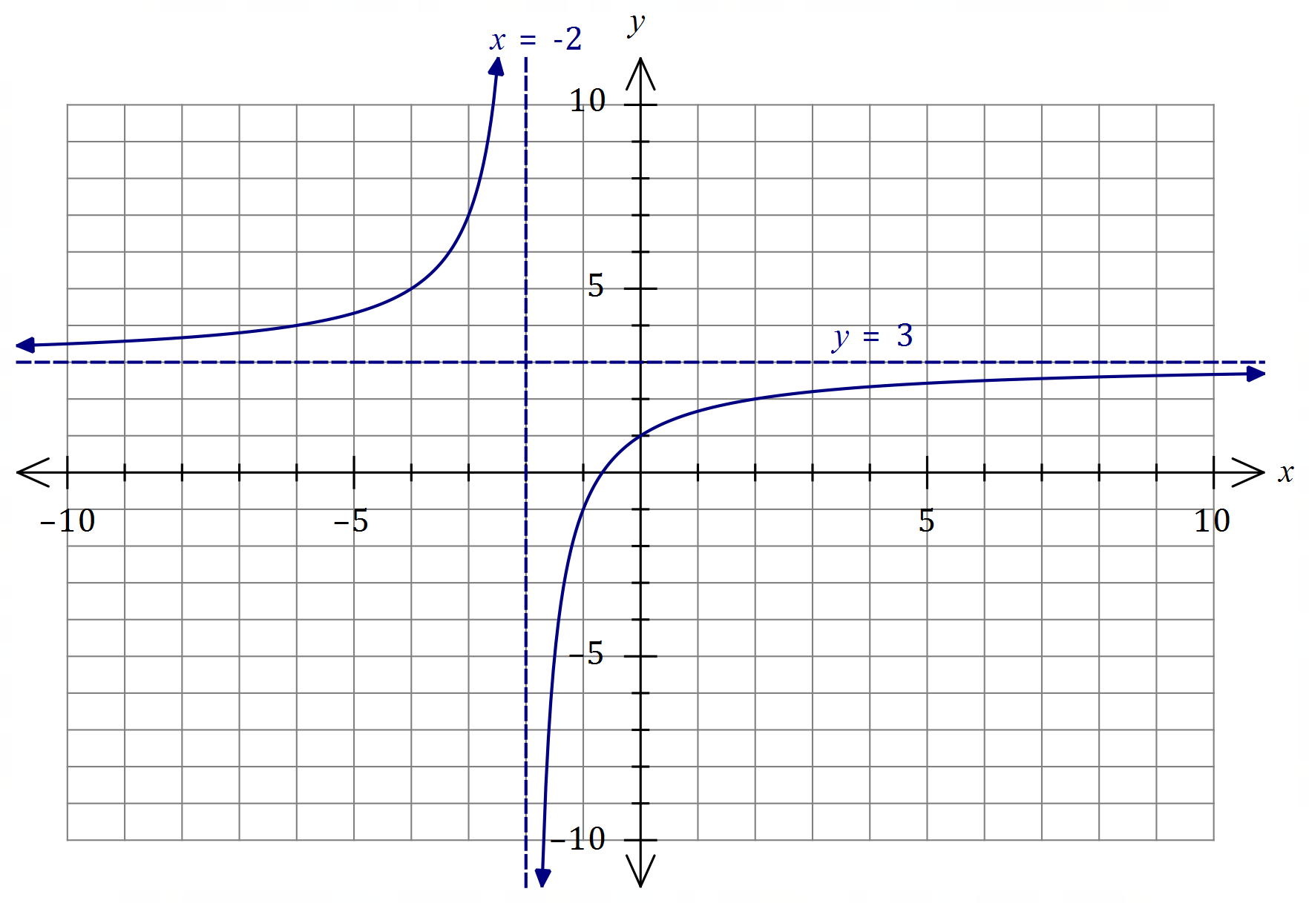
Solution
See graph
Specific behaviours
vertical asymptote with equation
horizontal asymptote with equation
✓ $y$-intercept and graph for $x>-2$
✓ remainder of graph

Question 20 (11 marks)
(a) Determine the area of triangle $PQR$ when $∠PQR=26°$, $∠PRQ=122°$ and $PQ=57$ cm.
(4 marks)
Solution
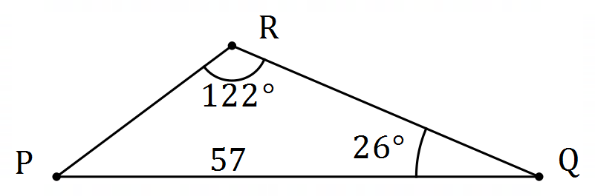

$$\frac{q}{\sin{26°}}=\frac{57}{\sin{122°}}⇒q=29.46$$

$$\text{Area}=\frac{1}{2}\left(57\right)\left(29.46\right)\sin\left(32°\right) \\ =445 {\text{cm}}^{2}$$

Specific behaviours
sketch of triangle
✓ correct use of sine rule
✓ length of second side
✓ correct area

(b) The area of triangle $ABC$ is $96$ cm², $∠ACB=30°$ and $2BC=3AC$ as shown in the diagram. Determine the length of $AB$. (4 marks)
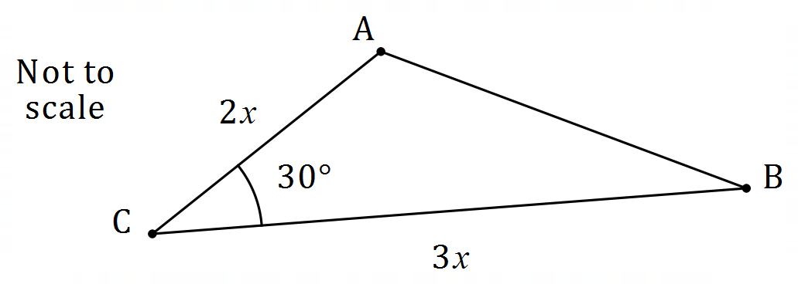
Solution
$$\frac{1}{2}\left(2x\right)\left(3x\right)\sin\left(30°\right)=96 \\ x=8$$

$${AB}^{2}={16}^{2}+{24}^{2}-2\left(16\right)\left(24\right)\cos{(30°)} \\ AB=12.92 \text{cm}$$

Specific behaviours
area equation
✓ value of $x$
✓ cosine rule
✓ length of $AB$

(c) In triangle $ABC$, $AC=65$ cm, $AB=44$ cm and $∠ACB=37°.$ Determine the smallest possible area of the triangle. (3 marks)
Solution
$$\frac{65}{\sin{B}}=\frac{44}{\sin{37°}}$$

$$B=62.75° \text{or} 117.25°$$

For smallest area need $∠A$ to be small as possible:

$$A=180°-37°-117.25°=25.75°$$

$$\text{Area}=\frac{1}{2}\left(65\right)\left(44\right)\sin{25.75°} \\ =621 {\text{cm}}^{2}$$

Specific behaviours
size of angle $B$
✓ smallest size of angle $A$
✓ correct area

Question 21 (8 marks)
The graph of $y=a+b\sin{(x-c)}$ is drawn below, where $a, b$ and $c$ are positive constants.

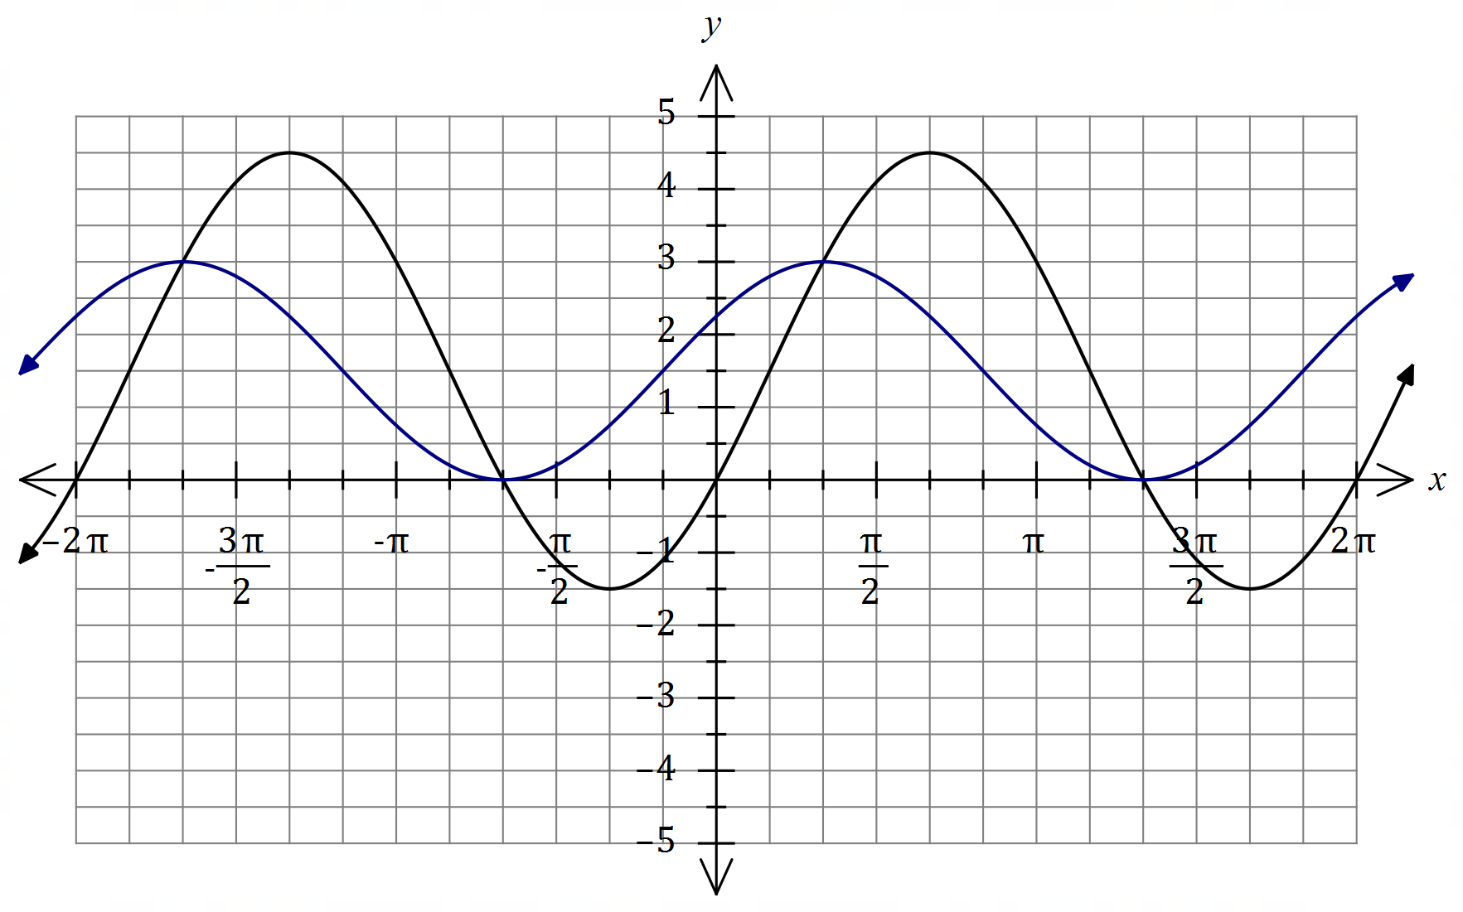
Solution (b)
See graph
Specific behaviours
both maxima
✓ both minima
✓ smooth curve

(a) Determine the value of $a$, the value of $b$ and the value of $c$, where $c<π$. (3 marks)
Solution
$$a=1.5, b=3, c=\frac{π}{6}$$

Specific behaviours
value of $a$
✓ value of $b$
✓ value of $c$

(b) On the same axes, draw the graph of $y=a+\begin{matrix}b \\ \overline{2}\end{matrix}\sin\left(x+c\right)$. (3 marks)

(c) Solve $b\sin{(x-c)}=\begin{matrix}b \\ \overline{2}\end{matrix}\sin\left(x+c\right)$ for $-π≤x≤π$. (2 marks)
Solution
Using intersection of graphs:
$$x=-\frac{2π}{3}, x=\frac{π}{3}$$

Specific behaviours
a correct solution, anywhere
✓ two solutions as given

Supplementary page

Question number: _________

© 2020 WA Exam Papers. Applecross Senior High School has a non-exclusive licence to copy and communicate this document for non-commercial, educational use within the school. No other copying, communication or use is permitted without the express written permission of WA Exam Papers. SN002-152-4.

